OS External Practical Exam

Name- Arpit Agarwal

Enrollment No-A20405220102

Q1. Write a C program to count the occurrence of each word and total words in a file.

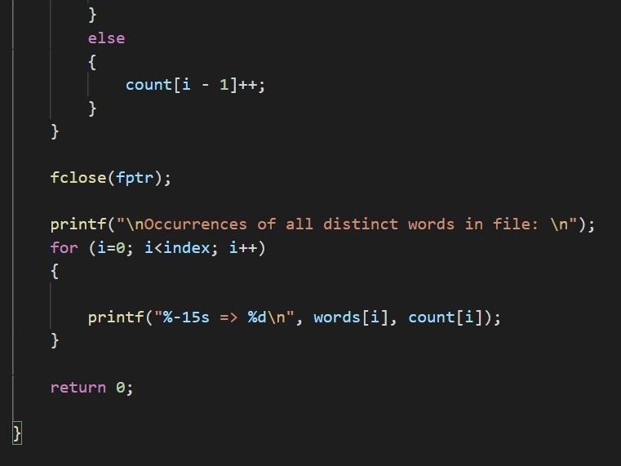

Output:

Q2. Write a C Program for Shortest Job First Scheduling.

Output:

